Four Seasons Auction Preview Reflects Restaurant’s Rich History
By Nancy Lazarus on Jul. 25, 2016 - 10:15 AM
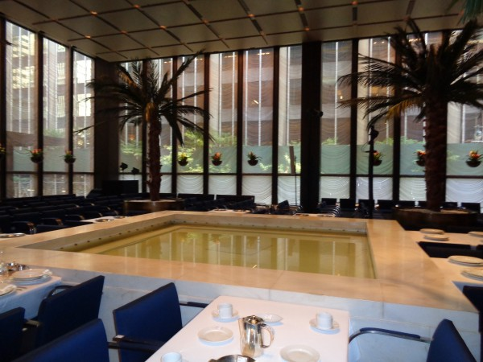
The Four Seasons pool room was the coolest spot in midtown Manhattan on Friday morning, resembling a spa more than a renowned restaurant for power brokers. The chairs set up for the auction were empty, but a packed house is expected on Tuesday morning to bid on all the contents. The air conditioner and bubbling water were among the only audible sounds during the auction preview, which continues until early afternoon today.
During our visit, the former patrons were out of town at their summer houses, and no waiters and bartenders were around anymore, either. In their place were photographers and security personnel. Co-owner Julian Niccolini was on the phone in the grill room, and we overheard him inviting the caller to stop by, saying, “Come on over, it’s an open house this weekend!”
All the furnishings and fixtures were tagged with lot numbers, from Ludwig Mies van der Rohe’s black leather Barcelona chairs to Eero Saarinen’s white enameled aluminum tulip chairs in the ladies room. The tableware with the iconic four trees logo was on display in all the seating areas, even on the grill room’s balcony, aka “Siberia”. Also for sale: the awning signs from the outside entrance, a sausage grinder from the kitchen, caviar bowls and a zabaglione server.
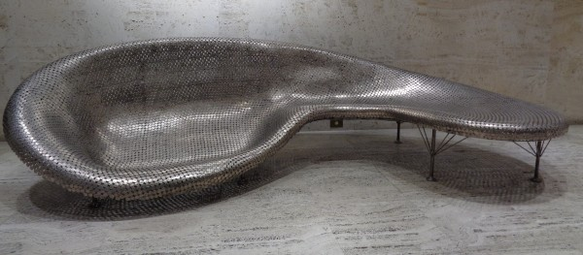
Picasso’s Le Tricorne, the tapestry-curtain mired in controversy that used to adorn one of the walls, is now on view at the New York Historical Society. But the preview featured other expensive or notable artworks: Johnny Swing’s “Murmuration”, a sculptural sofa of welded nickels and stainless steel in the downstairs entrance (auction estimate: $100,000 – $150,000) and “EAT”, a Robert Indiana screenprint, estimated at $1,000 – $1,500. (though likely to sell for more)
Much has been written about the power meals that took place at The Four Seasons over its storied 57-year history, along with the media and corporate executives that frequented the restaurant, likeAnna Wintour, Martha Stewart and Donald Trump. Among the items on display at the preview that serve as a reminder of how times have changed were the ashtrays. While there were no business cards left, we did take home a matchbook as a final memento.

